Project Timeline

Fall 2017 EC327 A1

Group Name: Gamer

Group Members:

Henry Bojanowski

Opara Chukwuemeka Emmanuel

Qian Zhang

YuHang He

JinHyun Park

|  |  |
| --- | --- |
| Nov.13 | Meeting I, team built |
| Nov.16 | Meeting II, brainstorm of ideas |
| Nov.28 | Meeting III, idea decided and further discussed, app started |
| Dec.2 | Meeting IV, office hour lecture, app building |
| Dec.3 | Meeting V, idea further discussed, app building |
| Dec.7 | Meeting VI, functions of the app discussed and created, the interface modified |
| Dec.9 | Meeting VII, video shot and edited |
| Dec.10 | App last modified, all documents and video uploaded |

Nov.13 Monday Meeting I

* Team built: *Gamer*
* Member and roles:

Henry Bojanowski  
 JinHyun Park

Opara Chukwuemeka Emmanuel

Qian Zhang

YuHang He

Nov.16 Thursday Meeting II

* Attendance: Henry, Jin, Emeka, Qian, YuHang
* Goal: brainstorms all possible ideas
* All ideas described :
  + - * Idea 1: create a game similar to *2048*1;
      * Idea 2: create a Rhythm game which randomly generates games/levels for any song on ur phone.
      * Idea 3: Finds out how far you are away from multiple bus stops, picks which one is best option to choose which.
      * Idea 4: Options for registration: there are several choices for different lectures, labs, and discussion, and the time always conflict, so it will be hard to register all classes with no time conflict.
      * Idea 5: Like Facebook pages for individual busses where people taking the bus can post info about it.
      * Idea 6: Calendar for classes. Professor can update the calendar and share updates with students.
      * Idea 7: Video tutorial app/player. When viewers play vids/tutorials, vids will automatically freeze/pause where the uploader thought necessary and the viewer can jump between different freeze points in the vid.
      * Idea 8: Meta Calculator game, which is a social commentary on students’ over reliance on calculators which is also a metaphor on people’s over reliance on technology.

Nov.28 Wednesday Meeting III

* Attendance: Henry, Jin, Qian
* Goal: decide which idea to be used in the app, and print the page on Android simulator
* Events record:
  + Decided to apply Idea 8, creating a Meta Calculator Game;
  + Project further discussed: Meta Calculator game that is a social commentary on students’ over reliance on calculators which is also a metaphor on people’s over reliance on technology. (BS reasoning-ception)
    - * Looks like a normal calculator
      * Calculator starts talking to user via text (and audio?)
        + “I am a sentient Calculator run by a super secret AI, I will only allow those whom I find worthy to have the honor is using me.
        + “To test your worthiness I will ask a few math questions and only if you answer all of them will I find you worthy.”
    - Calculator asks math question through the calculator display
      * + Ex. “2+2=
        + “Have to type in the answer through the keypad and the number typed will be displayed after the “=”
    - IF user don’t answer all the question correctly:
      * + Calc will say “You couldn’t even answer a simple question like that!?!? YOU ARE NOT WORTHY”
        + Then the app will self delete from the phone.
    - IF user answer all the questions correctly
      * + Calc will say”YOU ARE WORTHY”Game will end and you will be able to use the calculator like a normal calculator app
    - Bonus Level: Aliens are trying to hack into your trusty
  + App Update : successfully displayed a calculator on android simulator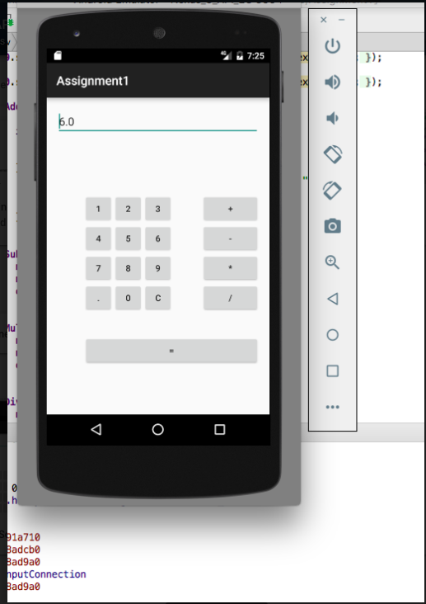

Dec.2 Saturday Meeting IV

* Attendance: Henry, Jin, Qian, YuHang
* Goal: learn how to clone repository from Github and push the code after editing, so all members could write and update the code separately;
* Events recored:
  + Office hour lecture:
    - Introduction of Github, Android Studio, Branches
  + Project Update: successfully uploaded local files onto Github; 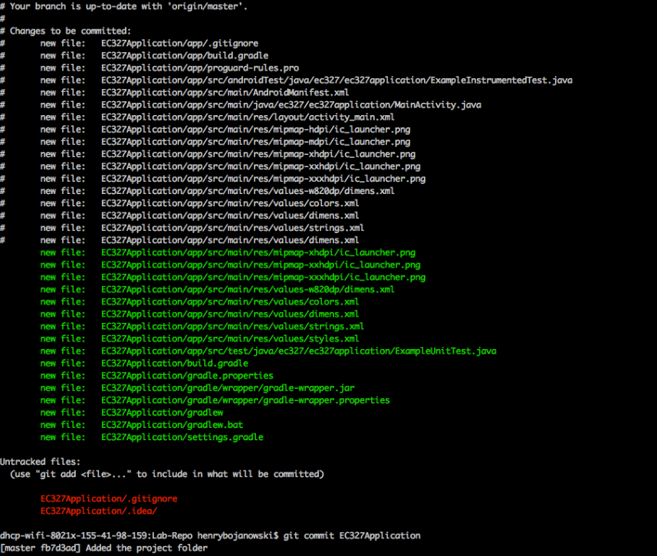

Dec.3 Sunday Meeting V

* Attendance: Henry, Jin, Emeka, Qian, YuHang
* Goal: Design the interface of the projects, and create the code
* Events record:
  + The main interface of the app is decided. There are three parts of the interface, the top one is where the question and texts are displayed, the mid one will be the keyboard of calculator, and the bottom one is the ENTER button.
  + The code for presenting the interface is created.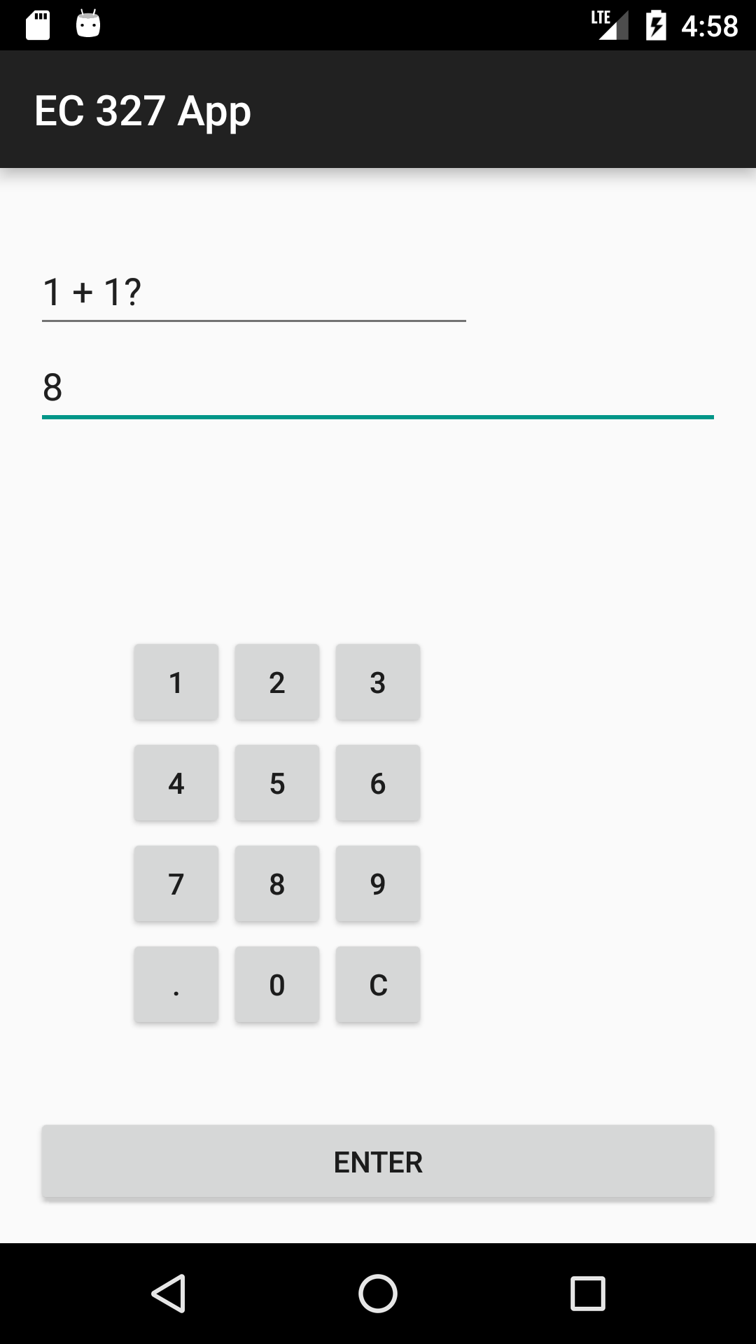

Dec.7 Thursday Meeting VI

* Attendance: Henry, Jin, Emeka, Qian, YuHang
* Goal: discuss and decide all the functions of the app, create the code, and modify the interface
* Events records:
  + Functions decided: the operation buttons of the calculator are disabled initially, and there are mathematic questions displayed. The user needs to calculate the result of the question and enter the answer on his or her own. After all the questions are answered, those operation buttons will be activated based on the user’s score.
  + Codes for what described above are created.

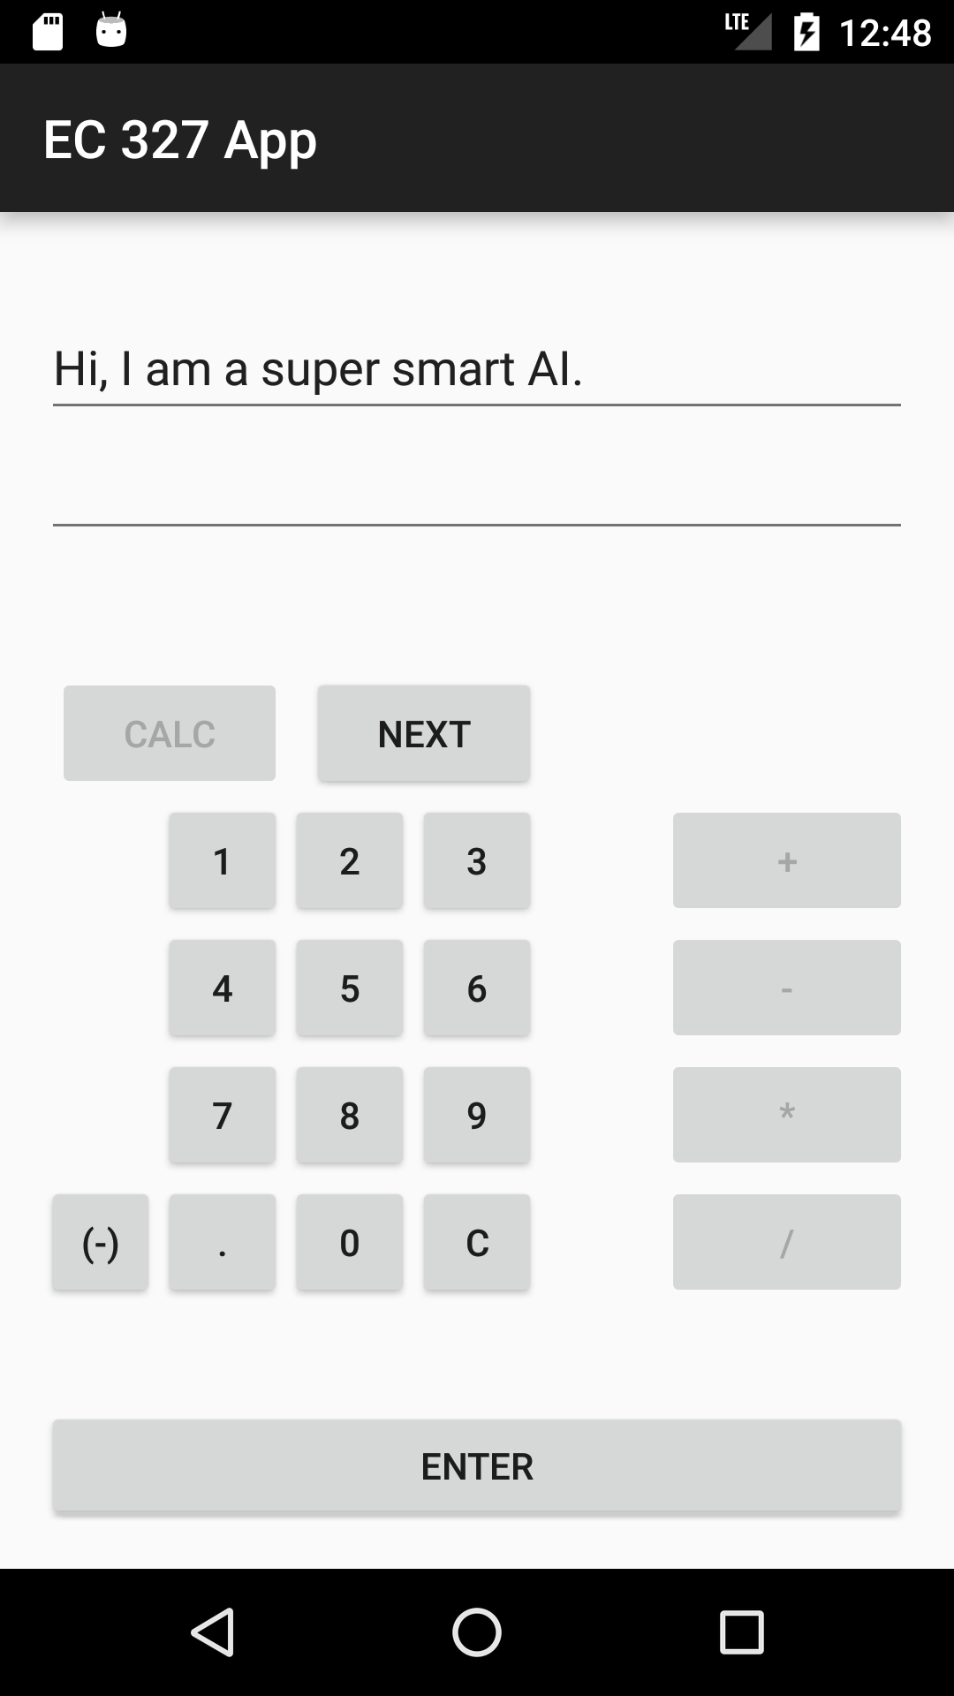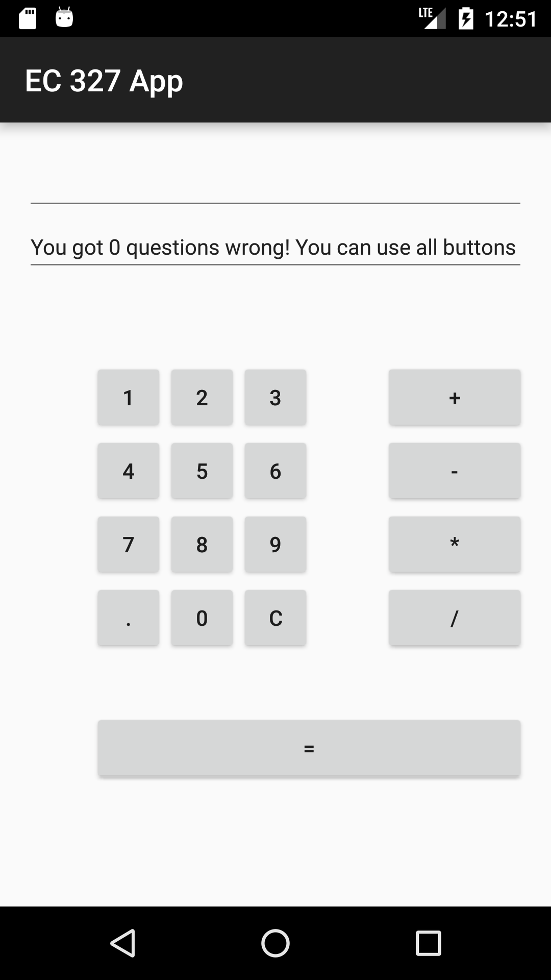

• Home page created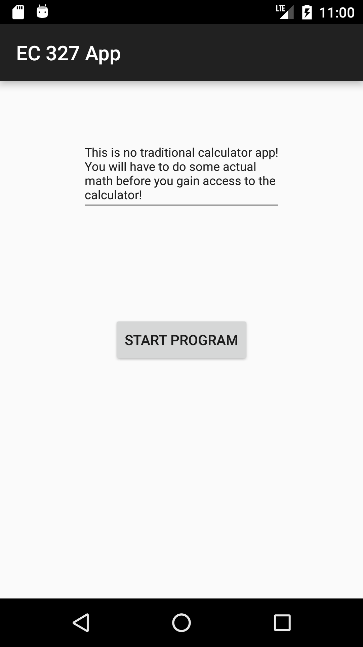

Dec. 9 Saturday Meeting VII

* Attendance: Henry, Jin, Emeka, Qian, YuHang
* Goal: finish all the document files, video shot and edited
* Events record:
  + Code modified, all the mathematics questions are being random now
  + Video shot and edited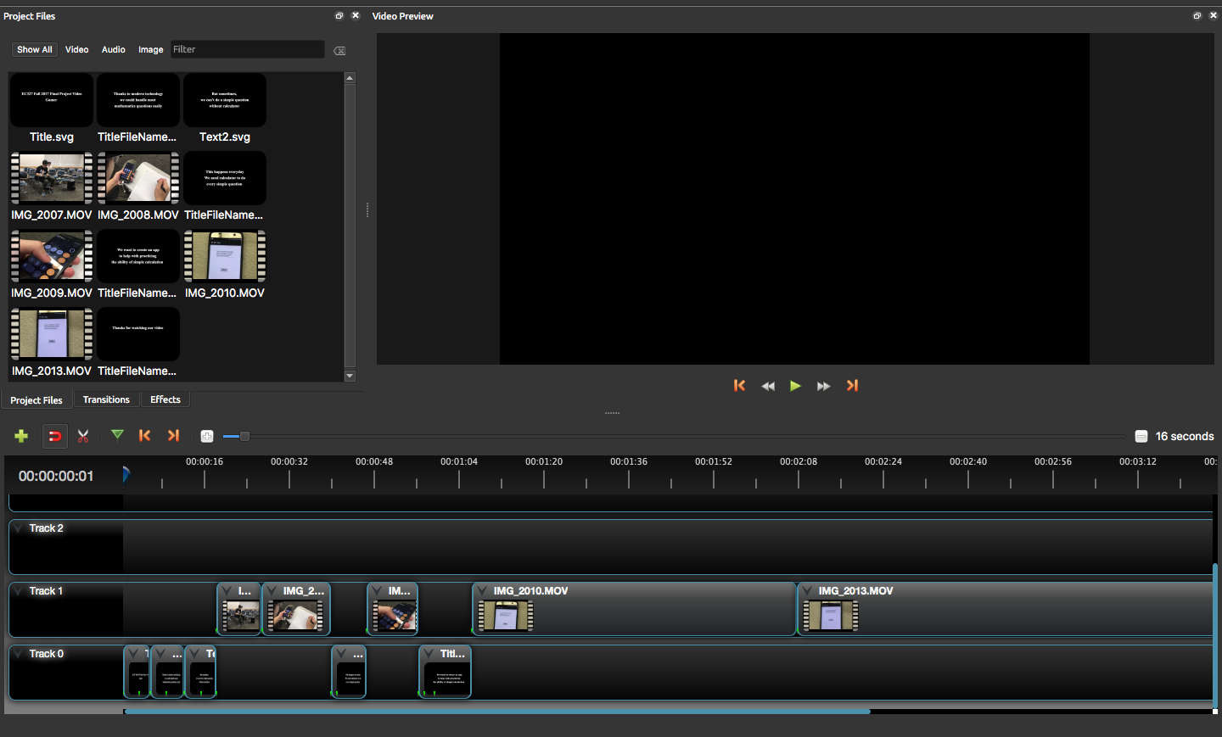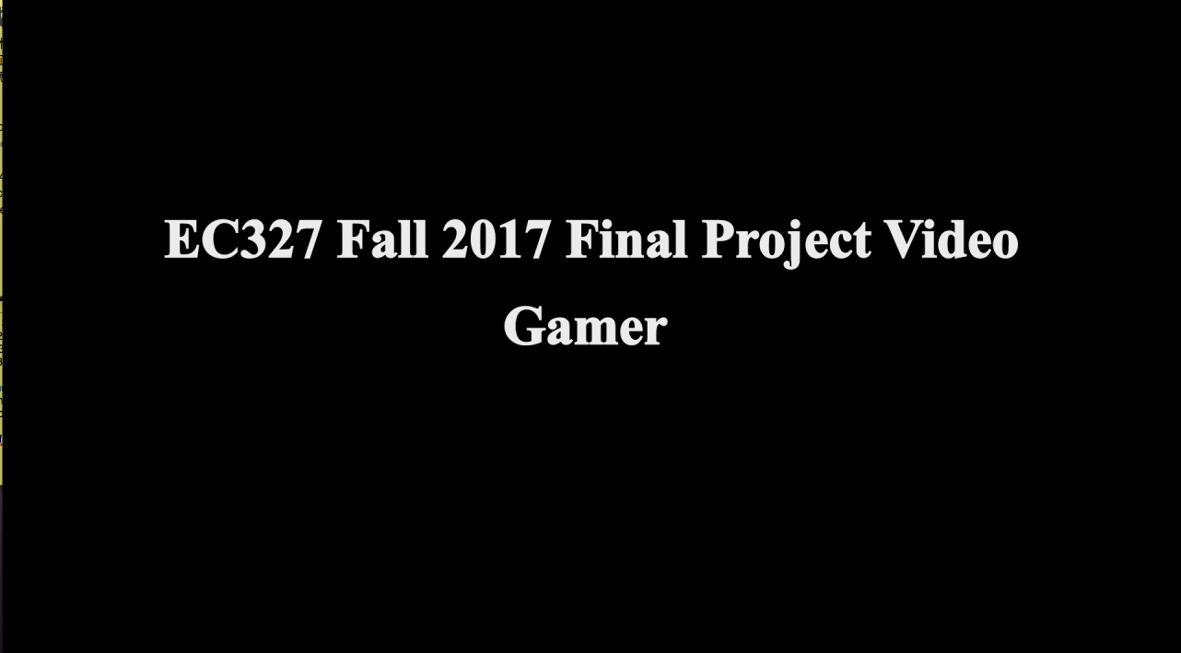

Dec. 10 Sunday

* Goal: finish the code and all requited document files, submit them;
* Events record:
  + Load page added to the app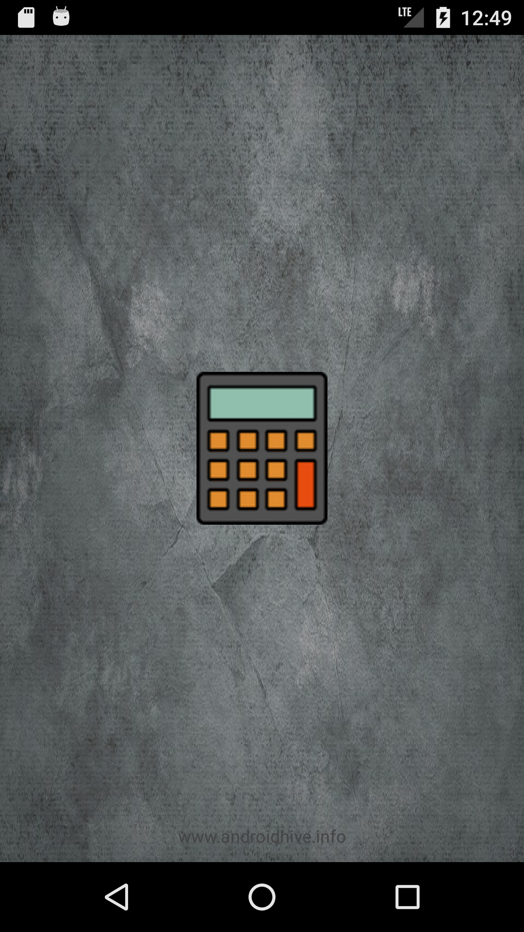
  + All code and documents file submitted, video uploaded, project done